## Object

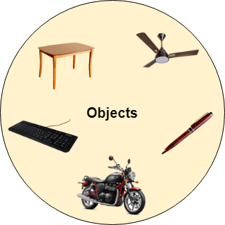

Any entity that has state and behavior is known as an object. For example, a chair, pen, table, keyboard, bike, etc. It can be physical or logical.

An Object can be defined as an instance of a class. An object contains an address and takes up some space in memory. Objects can communicate without knowing the details of each other's data or code. The only necessary thing is the type of message accepted and the type of response returned by the objects.

**Example:** A dog is an object because it has states like color, name, breed, etc. as well as behaviors like wagging the tail, barking, eating, etc.

## Class

*Collection of objects* is called class. It is a logical entity.

A class can also be defined as a blueprint from which you can create an individual object. Class doesn't consume any space.

**DIFFERNCE IN A LIBRARY AND PACKAGE**

In summary, packages are a way to organize source code within a project, while libraries are precompiled collections of classes that can be reused across multiple projects.